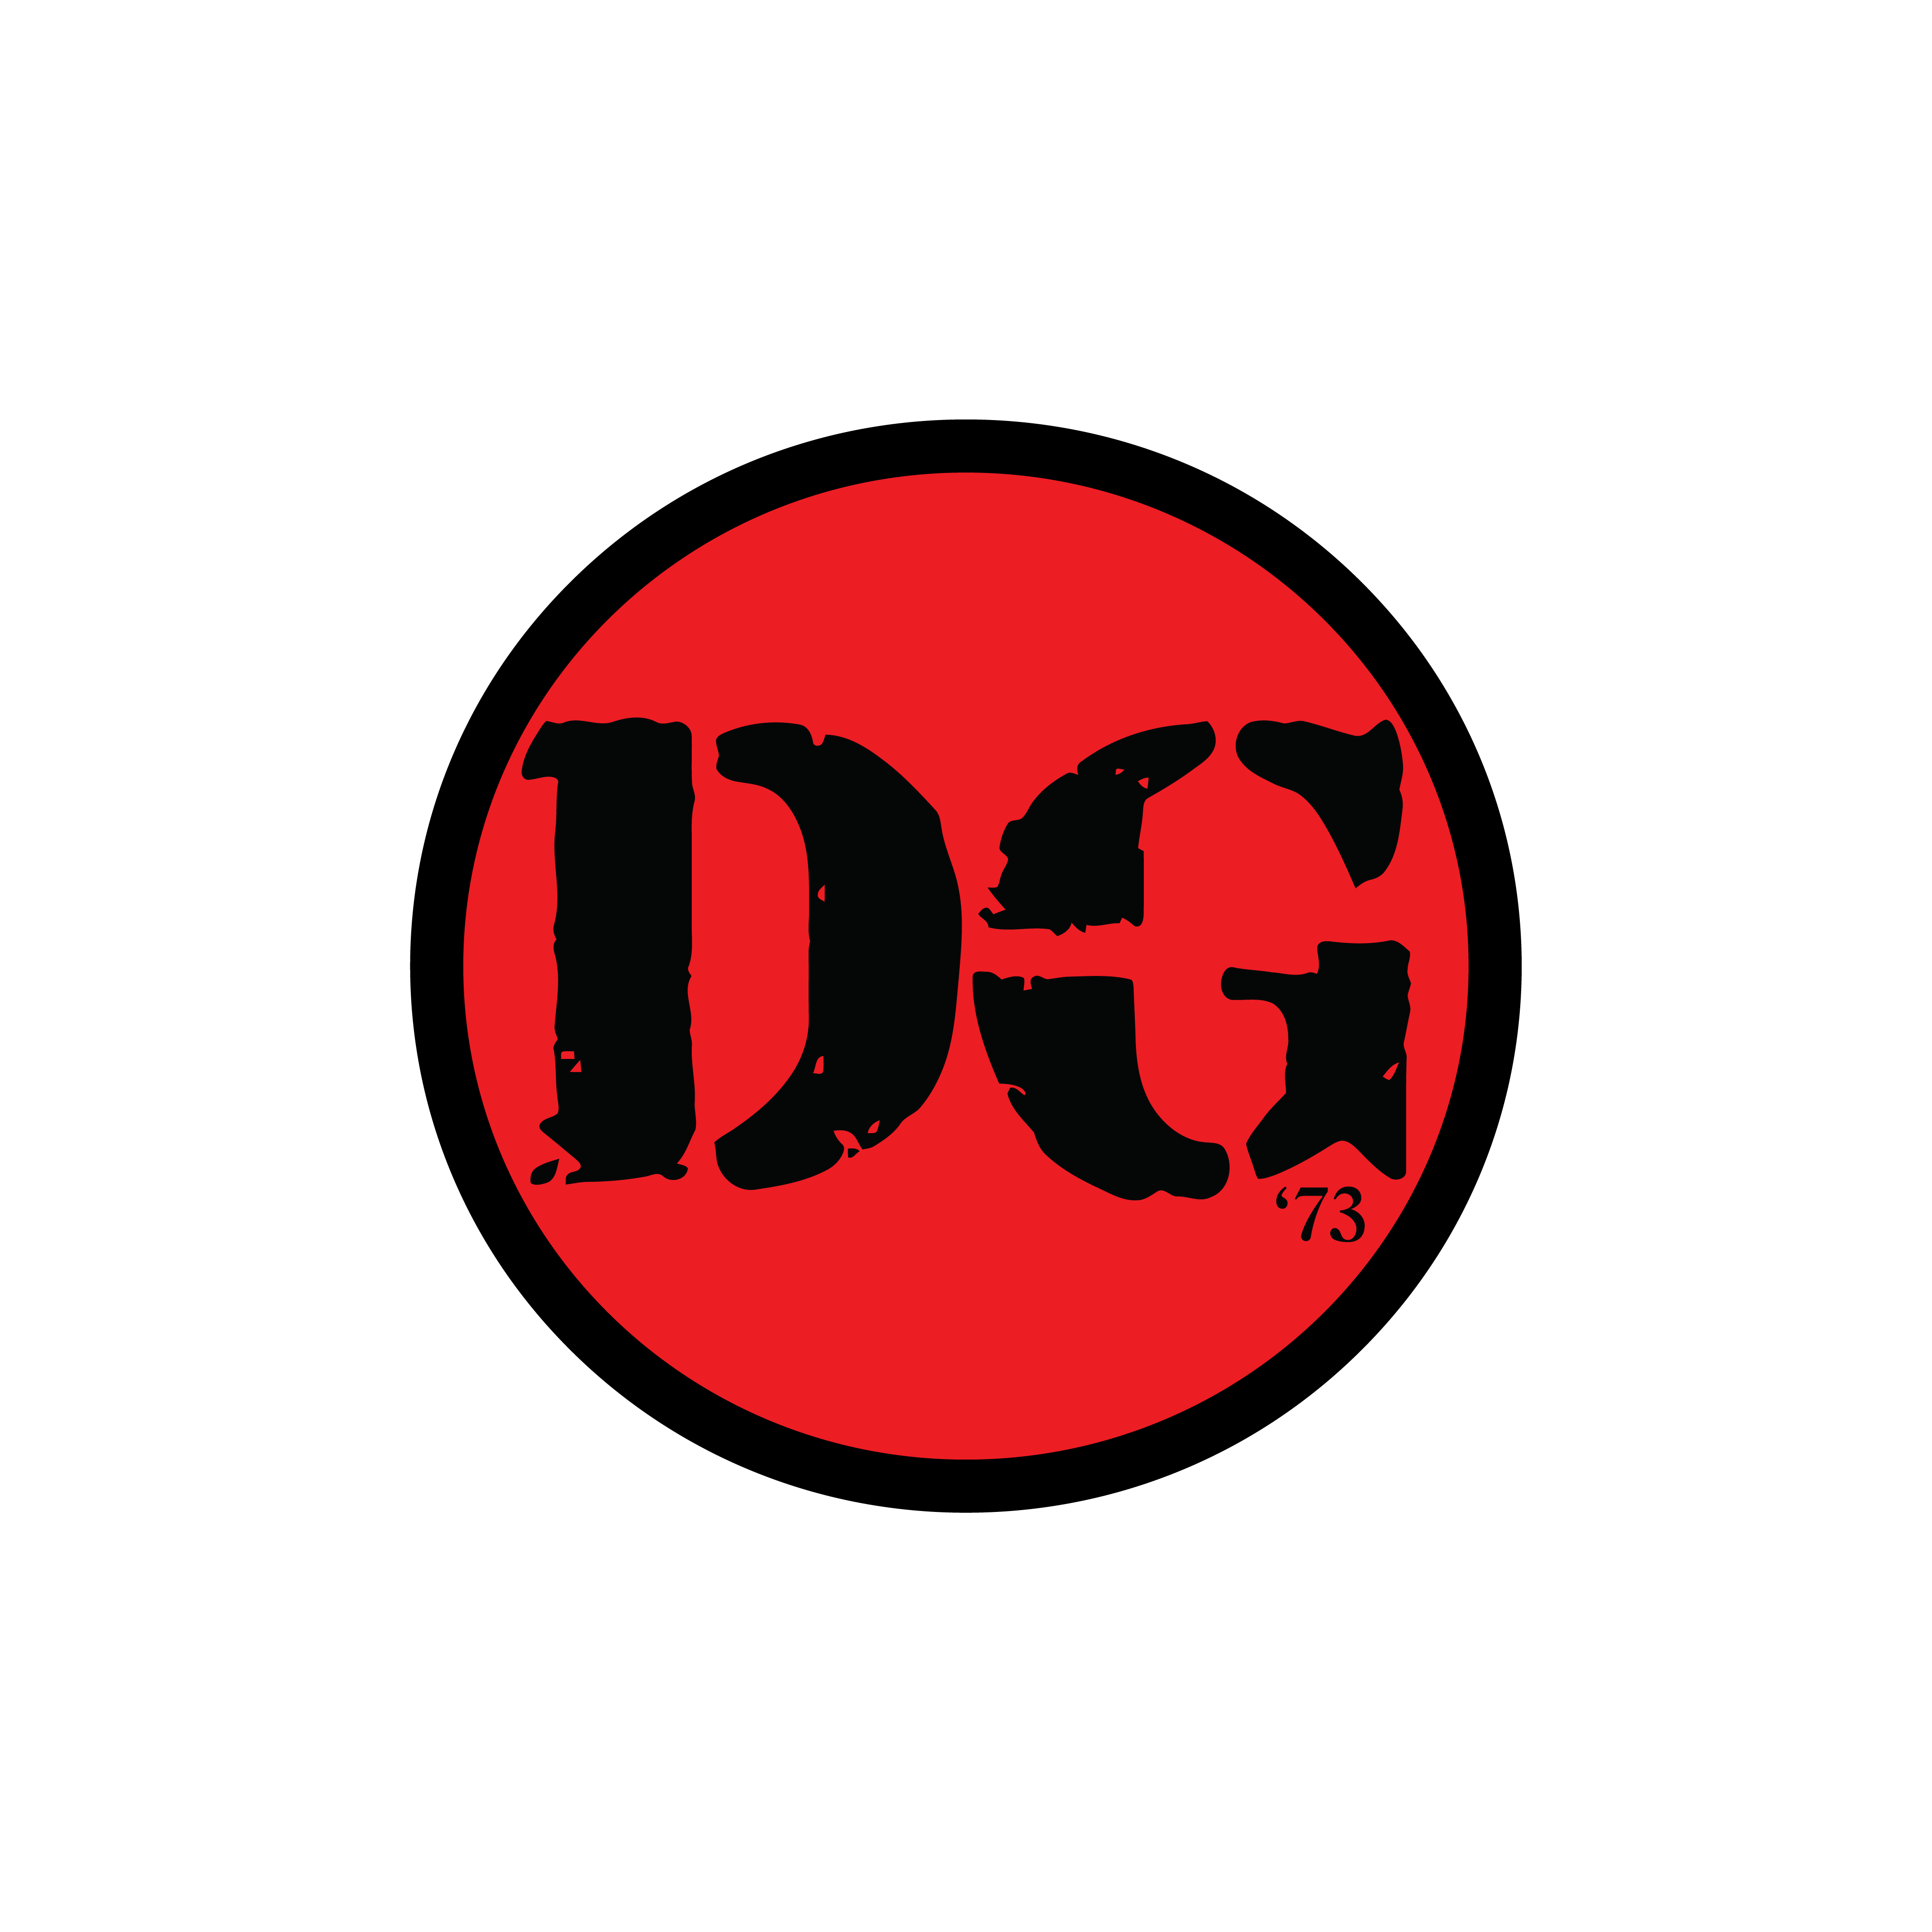
Kids Board Breaking Requirements by Belt Rank

White Belts - Palm Strike

Orange Belts – Hammer Fist

Yellow Belts – Front Kick

Green Belts – Inside Knife Hand

Purple Belts - Elbow

Blue Belts – Side Kick

Brown Belts – Jumping Front kick, 1 obstacle

Red Belts – Skipping Side Kick

X – Dan Bo – Flying Side Kick

